CoLab – Design Document
Computer Science 319
The Squirrels

Ian Dallas, Amelia Gee, Justin Nelson, Wayne Rowcliffe

Version | Initials | Date | Comments
1.0 | AG | 04/19/09 | Created initial document
1.1 | JN | 04/23/09 | Added Design and Overall Evaluation
1.2 | WR | 04/23/09 | Added Major Decisions and Challenges
1.3 | AG | 04/23/09 | Added Class Diagrams
2.0 | AG, JN, WR | 04/23/09 | Added Product Description

Product Description – Team

CoLab: A collaborative lab environment designed to enable users to simultaneously edit documents from different computers.

CoLab allows users to create their own personal space for collaborative team work sessions. While in this Room users can:

- Chat
- Add files to projects
- Save files to their local computer
- Simultaneously edit documents

CoLab provides a simulated team coding environment where it feels like everyone is in the same room.

The main principle of CoLab is based on CoLab Rooms – a place where teams can meet and collaborate. A CoLab Room can have any number of members and documents. Members of this Room can view or edit documents and their fellow Room members can view changes as they take place.

Documents are split into subsections. A CoLab Room member may edit one subsection at a time. While they are editing this section no other user can edit its content.

But wait, there’s more!

Built into each CoLab Room is a privilege hierarchy. The system consists of three levels:

- Admin – The admin is the owner of the room and is responsible for promoting/demoting other Room members as well as having all the document editing capabilities of a participant
- Participant – Participants are able to add, remove, and edit documents
- Observer – Observers can watch changes happening to the documents but have no editing capabilities

All users can save copies of the documents to their local computer at any time.

CoLab also features a chat window where Room members can communicate with the group or send private messages to another Room member.

Users can run their own CoLab servers and host their own meetings at the convenience of their team.

Major Decisions – Wayne

Many of the decisions described below are such that choosing any one alternative directly affects the logical choices for one or more separate decisions. A rationale for each choice is given below.

Custom Protocol vs. HTTP

Perhaps the single most important factor in the design of CoLab was the initial intention of sending individual keystrokes to and from the server. Given that the average person can type 30 – 60 words / minute, each word containing multiple characters, potentially thousands of messages would be relayed between clients and the server every minute.

Given the nature of the HTTP protocol, CoLab messages would have been burdened with far more meaningless protocol than actual data. This would result in unacceptable bandwidth and lag increases.

For this reason, it was decided that CoLab should implement its own specialized protocol, with the goal of minimizing protocol length.

Custom Server vs. Servlets / Tomcat

From the minute we chose a custom protocol for CoLab, the use of Servlets became a non-issue. Since Servlets make use of the HTTP protocol, CoLab would be unable to communicate with a central server running Servlets on Tomcat.

In order to complete CoLab in accordance with the original vision, a custom server would need to be implemented. This server would need to emphasize minimal protocol bloat, quick response rates, and the ability to synchronize the actions of multiple CoLab users towards the end goal of creating a collaborative document.

Direct Sustained Connection vs. Periodic Connect and Refresh

With the decision to implement a custom CoLab server, the design options became virtually limitless. Since we would be coding the entire server from scratch, the internal workings were ours to choose.

One of CoLab’s main goals was to enable multiple users to quickly and collaboratively edit a single document. To achieve this, we would need to track who was editing which document, what changes they were making to that document, and who to notify of the changes.

With the periodic connect and refresh model, the client is completely in control of when to contact the server and ask for updates. Moreover, this connection takes time. If we were to provide the fluid, responsive service we envisioned, something quicker and more predictable would be needed.

By establishing a direct, sustained connection, the server gains the ability to contact the client. We also eliminate the connection delay. With hundreds of updates being sent every second, this delay would render the service unusable. Additionally, by allowing the server a direct connection to the client, emphasis is shifted towards the central server. Design-wise, it makes sense that a collaborative document should exist primarily in one place, and be edited by multiple people. This is much more intuitive than a document which exists in many places, attempting to remain synchronized over all.

With the direct connect design, clients could now contact the server to suggest updates, and the server could contact everyone immediately to reflect changes.

Swing vs. Webapp

At this point, any hope of creating a webapp was lost. Not only were we straying from the HTTP protocol, we were also opting to ditch Tomcat, and to establish and maintain direct connections to each client.

Swing became the de facto choice. All members of the development team had at least some experience using Swing, and as the project would be coded in Java, there was no incentive to use anything else.

Multiple SubSections vs. Single Multi-caret Document

Throughout all of the previous design decisions, we maintained the initial goal of responding directly to individual keystrokes and inserting the additions of multiple people directly into a single document.

Then we thought about how this could actually be implemented.

It immediately became clear that, although in theory the idea seemed workable, none of the developers actually had a valid, workable method to implement it. Originally a sort of multi-caret document was envisioned, where each user would have a caret located somewhere in the document for editing. Each user would be able to edit the documents without the other users' actions interfering with theirs.

Much of this concept stemmed from the idea that lines were more or less separate entities within the document, meaning that changes to one line would not directly affect the contents on another line. However, a line is really just a new line character. This meant that inserting a character at the beginning of the document effectively shifted any caret later in the document back a character. Implementing this sort of design in a fluid, reliable manner would be an intricate dance none of us was willing to undertake.

A different design was needed.

Learning from the shortcomings of the initial vision, namely the need to log each individual keystroke, relay it to the server, reposition all subsequent carets, and notify the client of the change, all without missing a beat; we decided to take a more modularized approach.

A Document would consist of multiple SubSections. Each SubSection would have an arbitrary length, and be editable by only one person at a time. In order to edit a SubSection, the user would need a lock on that section. Moreover, a user could hold only one lock at a time. SubSections would be completely independent of each other, each being individual entities in their own right. The overall Document would simply be a listing of multiple SubSections.

Since SubSections would be independent of each other, the need to log individual keystrokes was no longer imperative. Many of the previous decisions could probably go either way with this design, however, we stand by our choices, and believe them to be the best alternatives to make CoLab a success.

Major Challenges – Wayne

Synchronization

In order to successfully create a collaborative editing environment, the actions of multiple users need to be synchronized such that edits by multiple people affect the document uniformly and as expected. These means that changes by one user must be collaborated with changes by another user to create a single, unified document.

Fluidity

In order to create a collaborative environment that seems natural, changes must happen in a fluid, non-intrusive manner. The changes made by one user should not adversely affect the efforts of another user. Updates should be made as seamlessly and naturally as possible.

Usability

For CoLab to be successful, it needs to be user friendly. Interfaces must be intuitive and simple to use. A user should not be aware of the background processing needed to create a synchronized, fluid, collaborative editor.

Reliability

Most importantly, for CoLab to have any chance of succeeding, it must be reliable. Users must be confident that their contributions to the document will happen as expected, where expected, and when expected. A breakdown in any of the previously listed challenges constitutes a failure in reliability. In order to obtain a user base, CoLab must first be reliable.

Design Evaluation – Justin

The main problem that we had to solve was network connection.
Our Server is connected to many different Clients, and we had to create an easy way for Clients to connect to a Server and then not have to worry about any more network connections.
Our final design ended up with a system where once a Client or Server is instantiated, all of the network stuff happens automagically. In other words, all of the connections get set up upon construction of the components. On the Server side of things there is a ConnectionListener waiting for Clients to connect to the Server. The ConnectionManager grabs the information about the connection and creates a Client object on the Server side encapsulating all of the connection information.
Similar to that, when a Client connects to the Server, it gets an instance of a Server object which also encapsulates all of the connection information about the Server. Thus as far as an actual Server or Client implementation can tell, they are just calling methods directly on objects, instead of passing messages across the network.

Another major design issue was the problem with simultaneous editing on the same document. We solved this by breaking a document up into chunks and only allowing people to edit one section of a document at a time. We have our users obtain a lock on a section which they can then edit. If they then want to lock another section they must release the lock on the section they previously had. Users can also merge and split sections to add more flexibility to editing.

As far as things we would have done differently do, well, they don’t go far…
We probably should have decoupled the Client Side GUI from the Client implementation on the Client side. As it is now, the class is a huge mess, some 800 lines of code long at the time of writing this.

Overall Evaluation – Justin

Overall we feel the project was a success. Initially we were planning on sending every character along the tubes every time a key was pressed. This turned out to be a bad idea, and I think that where we ended up is a much better place.

One other road block we hit was debugging little problems once the bulk of the functionality was in the code. Or classes had become very large and our methods were undocumented. It was difficult for the people who wrote the code to remember what they did, not to mention people who were working on other parts. It made debugging a very difficult endeavor.

Class Diagrams – Amelia
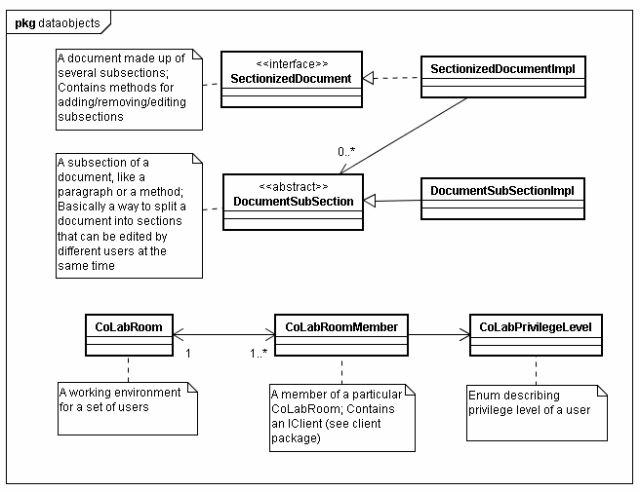

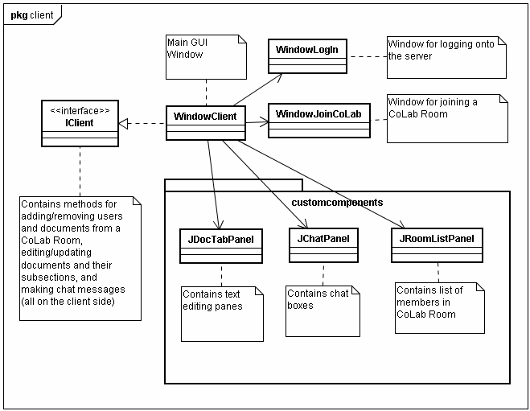

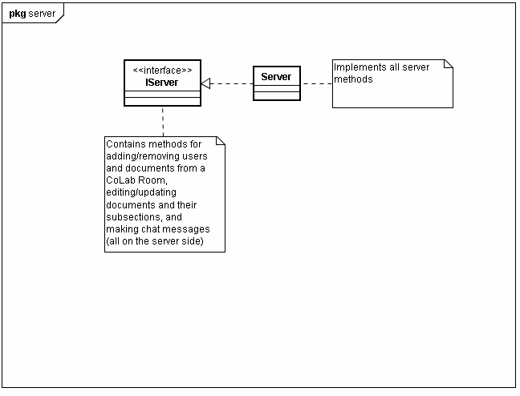
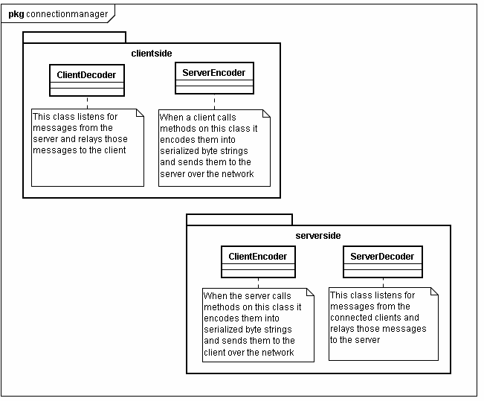
Sequence Diagrams – Ian

